Convert Guest user to Member

## Optional

Install-Module -Name AzureAD

Import-Module -Name Azure AD

## Connect to Azure

Connect-AzureAD

## Get the Guest Object ID

Get-AzureADUser -ObjectId "neo.powershell_gmail.com#EXT#@azsharper.onmicrosoft.com"

**Note the Object ID:** 505c0b23-74ab-400e-9b36-2a9fb478ef01

## Update User Type to Member

Set-AzureADUser -objectid 505c0b23-74ab-400e-9b36-2a9fb478ef01 -UserType “Member”

## Update UPN

To modify the login ID from the **Guest format** to a **standard format**, run this command:

Set-MsolUserPrincipalName -UserPrincipalName "neo.powershell_gmail.com#EXT#@azsharper.onmicrosoft.com" -NewUserPrincipalName "neo.powershell@cloudcxsoft.com"

## Set the Usage Location

Set-MsolUser -UserPrincipalName neo.powershell@cloudcxsoft.com -UsageLocation "US"

## Set a Default Password

Set-MsolUserPassword -UserPrincipalName "neo.powershell@cloudcxsoft.com" -ForceChangePassword $true

**Note the password displayed:** Zoq84654

The last step is to connect to either portal or myapplications URL and change the password during first login

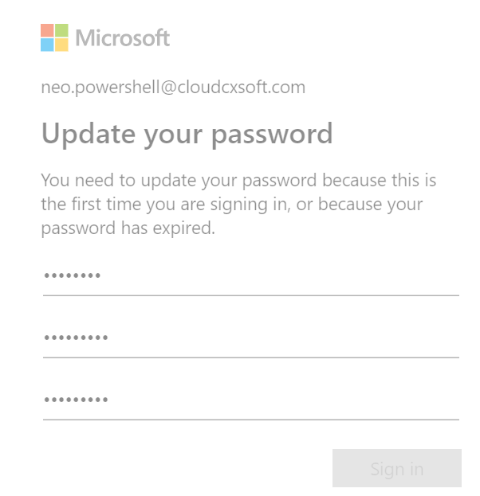

You can also verify the User Type status in portal or using this command:

Get-AzureADUser -SearchString "Neo"